State University of New York at New Paltz

Division of Engineering Programs

Department of Electrical and Computer Engineering

#### EGC320 Digital Systems Design

**Final Project: Game combo**

**Christopher Lepore**

**12/8/2020**

# Abstract

In this project a game was created using Verilog. The objective of the game is to flip switches 0 to 5 in the correct order given by the 7 segment displays before time runs out. There are 4 difficulties that can be controlled by switch 6 and 7, as the difficulty increases the number of switches that need to be flipped increase and the time given changes as well. In between rounds you can check your high score for each difficulty. Switch 8 and 9 are used to control which high score is shown.

## Table of Contents

## Introduction

The purpose of this project was to create a reaction game in Verilog where the player needs to flip the switches in the correct order before time runs out. In the game, the displayed a set of numbers on the 7-segment displays show the combination the player needs to match. Each 7-segment display has a correlating switch, for example HEX0 correlates with switch 0 (SW0). The number shown in that display tells the player when to flip the switch, so when HEX0 shows a 2 and HEX1 shows a 1, then switch 1 is flipped first and switch 0 is flipped second. Also, if the 7-segment display shows a 0 that means that switch is not part of the combination and should not be flipped. For example, if the display shows a combination of 0-0-0-3-1-2 that means the order the switches should be flipped is SW1 first, SW0 second, SW2 third, and switch 3 to 5 should not be flipped.

## Design Procedure

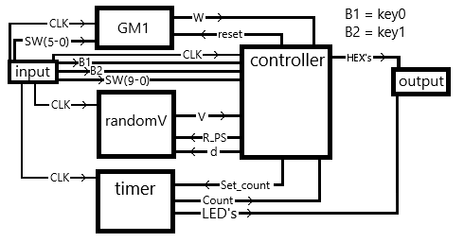

Figure 1 – game combo’s block diagram

|  |  |  |  |
| --- | --- | --- | --- |
| Table 1 | | | |
| Sw7 | Sw6 | d | x |
| 0 | 0 | 1 | 2 |
| 0 | 1 | 2 | 4 |
| 1 | 0 | 3 | 6 |
| 1 | 1 | 4 | 8 |

|  |  |  |  |
| --- | --- | --- | --- |
| Table 2 | | | |
| state | Set_count | R_PS | reset |
| S0 | 0 | 0 | 1 |
| S1 | x | 1 | 0 |
| S2 | 0 | 0 | 0 |
| S3 | 0 | 0 | 0 |

|  |  |  |
| --- | --- | --- |
| Table 3 | | |
| SW9 | SW8 | High score |
| 0 | 0 | Highscore_1 |
| 0 | 1 | Highscore_2 |
| 1 | 0 | Highscore_3 |
| 1 | 1 | Highscore_4 |

The overall design uses 3 modules to continuously produce the 3 necessary variables for the game which are an 18-bit vector “V”, a 1-bit variable “W”, and a 4-bit vector count. These modules are controlled by the controller through the wires – reset, d, R_PS, and set_count as shown in table 1 and 2. The controller then outputs 6 vectors from HEX0 to HEX5 to be shown on the “7 segment display”.

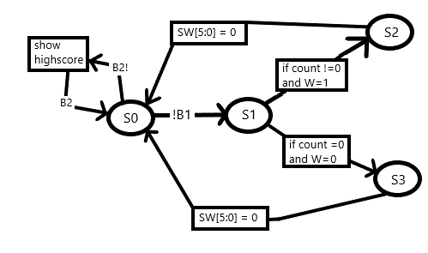

Figure 2 - controller state diagram

The controller module tracks the state of the game and determines the high scores for the player. As shown in Figure 2, S0 is the starting state for the program where the game is not being played. In state S0 the player can start the game by pressing key0, look at their high score by holding down key1 and set the difficulty the player wants to see using sw9 and sw8 as shown in Table 3, and they can set their difficulty using sw7 and sw6 if the round reads a value of 0 like in Figure 6. If sw7 and sw6 are changed in when the round is not 0 or the program is not in state S0 then there is no change until the player losses and the game goes back to round 0. Once the player loses the score is then compared with the high score for the same difficulty, if the score is higher than the game replaces it. In state S1, the game is being played and the 7-segment display shows the 18-bit vector from the randomV module as shown in Figure 7, 13, 14, 15. If the wire W form the GM1 module becomes a logic 1 before the count from the timer module reaches 0 then the state becomes S2(win state), if not than the state becomes S3(lose state). Once in state S2 or S3 the program then waits for switches 0-5 to all be flipped to logic 0 and then it returns to state S0. In state S2 the 7-segment display will show dash lines at the top and in state S3 they will show dashed lines at the bottom.

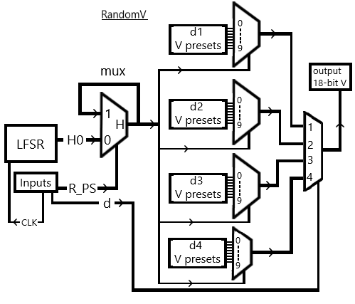

Figure 3 – RandomV module

The objective of the randomV module was to create a random 18-bit vector where every 3 bits represents a number to a total of 6 numbers. the module works by using a linear-feedback shift register (LFSR) that cycles a 4-bit register "H" to a number in between 0 and 9, this number constantly cycles until the controller sends a R_PS output of logic 1 (as the round is being played). then based off the difficulty "d" from the controller and the variable "H" a preset 18-bit vector is outputted.

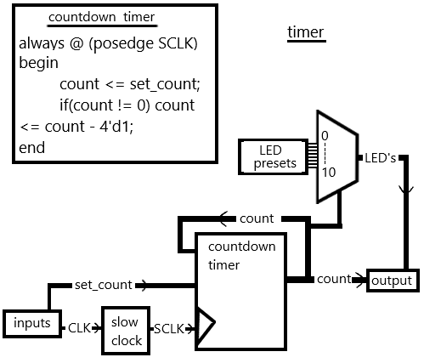

Figure 4 – timer module

The objective of the timer module was to create a 4-bit counter that counts down to 0 and control the LED's based off the counter. this works as follows- once the module is given a "set_count" of non-zero form the controller the counter register will decrease by 1 every slow clock pulse "SCLK" until the counter hits 0. while the counter is counting down the variable "set_count" as no effect. the count output is then put through a case statement to control the LED's.

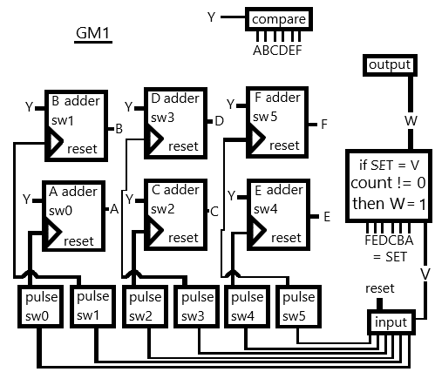

Figure 5 – GM1 module

The objective of the GM1 module was to collect the inputted combination of the switches the player inputted and then test if it matches the combination from the randomV module. the player's combination was recorded through outputting a pulse every time a switch is flipped to logic 1, then every time there is a pulse the correlating register is assigned a value of "Y" increment by 1. the register "Y" is derived from comparing each of the 6 registers (A, B, C, D, E, F) and assigning the highest value to "Y". once the player matches the combination the wire "S" will be assigned to a logic 1 through the code - "assign SET = {F, E, D, C, B, A}; assign S = (SET [17:0] == V[17:0]);" where "V" is the vector created by the randomV module. then once "S" goes from a logic 0 to 1 it checks if the count has reached 0, if not than the output register "W" is set to 1 and the player won the round. after each round the controller outputs a logic 1 for reset which sets registers A, B, C, D, E, F, and W to a value of 0 so that the next round can be played.

## Verification

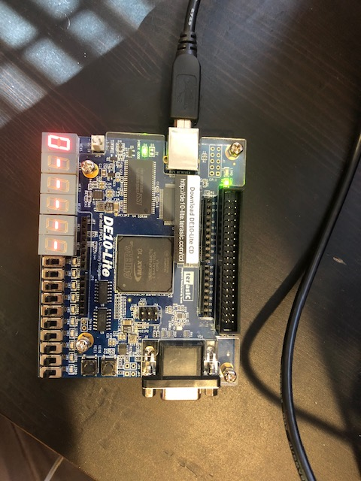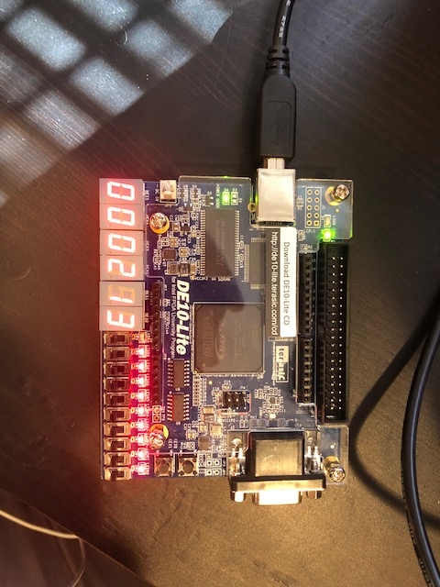

Figure 6 – state S0 Figure 7 – state S1, difficulty 1

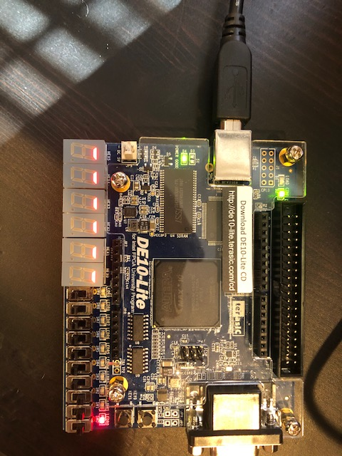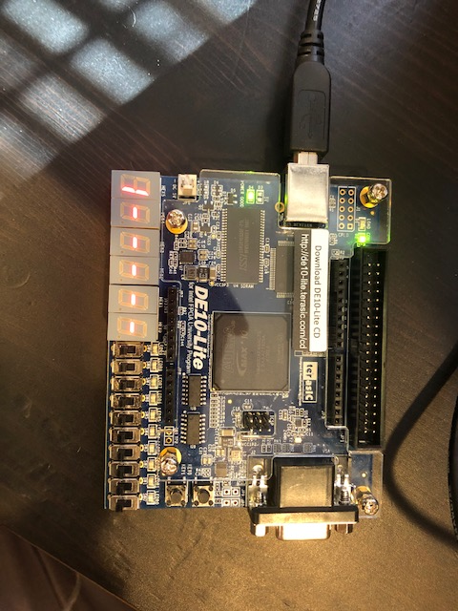

Figure 8 – win state Figure 9 – state S0, round increase

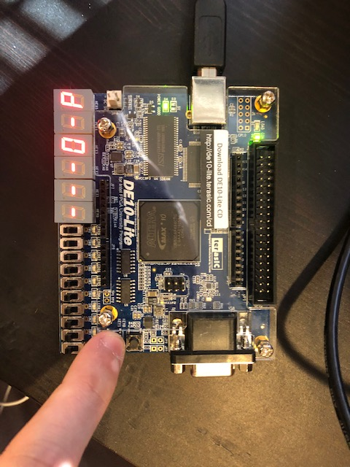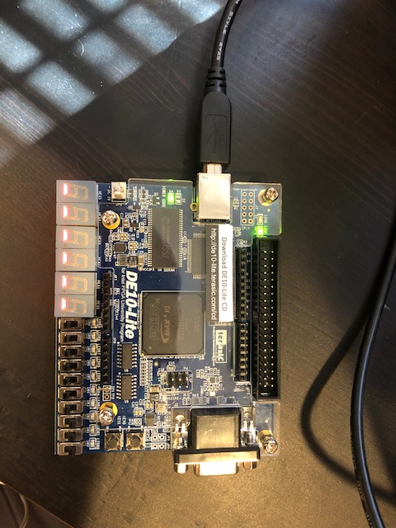

Figure 10 – high score, difficulty 1 Figure 11 – loss state

before round loss

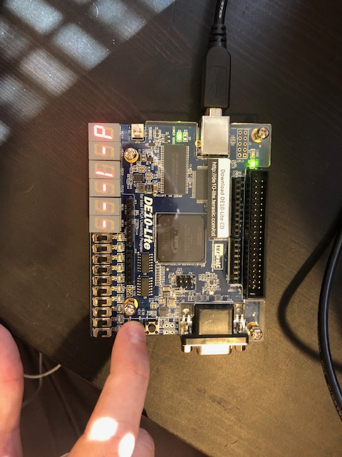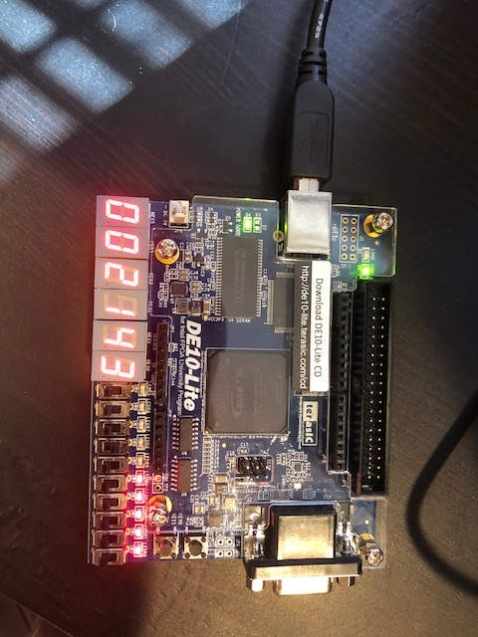

Figure 12 – high score, difficulty 1 Figure 13 – state S1, difficulty 2

after round loss

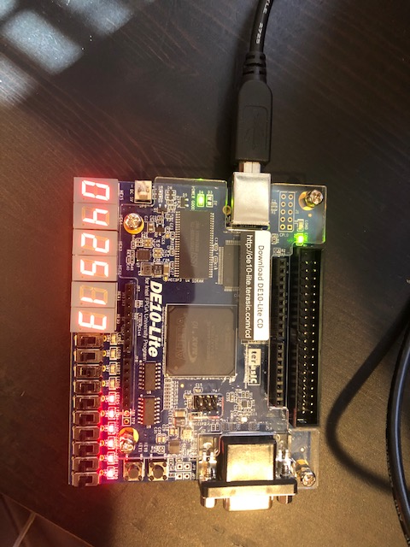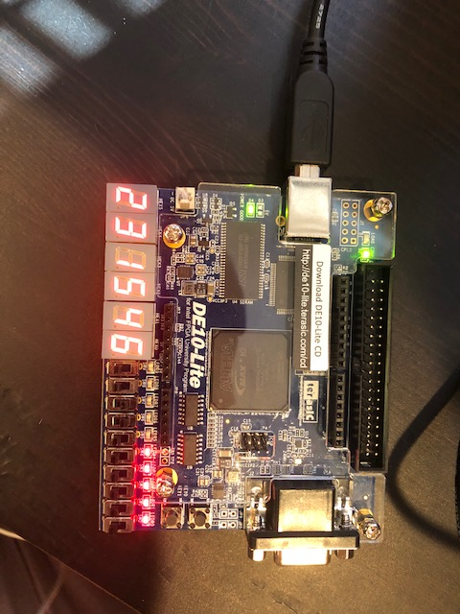

Figure 14 – state S1, difficulty 3 Figure 15 – state S1, difficulty 4

## Conclusions

This project created a game meant to test the reaction time of the player by flip 6 switches in the order given by the 7-segment display before the timer runs out. The program will keep track of the players score until the player loses then if they beat their high score then it will be replaced. The main problem faced was finding a way to record the players combination by incrementing by 1 each time a switch is flipped and assign it to its correlating register without affecting the other registers. This was solved in the end by generating 1 clock pulse every time a switch is flipped to logic 1 and then increment by 1 based on the pulse. Another issue was finding the correct design for the controller to reset the game variables so the next round can be played and so each state is reached when it is supposed to. This was solved through trial and error to see which design will produce the correct results. Once these problems were fixed the result of the project was a fully functioning game that tested the players reaction and able to run an endless number of rounds and keep track of the players high scores.

## Appendix

module game_combo (SW, B1, B2, CLK, LED, HEX0, HEX1, HEX2, HEX3, HEX4, HEX5);

input [9:0] SW;

input B1, CLK, B2;

output [0:6] HEX0, HEX1, HEX2, HEX3, HEX4, HEX5;

output [9:0] LED;

wire [17:0] V;

wire [3:0] count, set_count, d;

wire W, sp, R_PS, reset;

randomV vector (R_PS, d, CLK, V);

timer t (set_count, CLK, count, LED); //main code

GM1 G (reset, SW[5:0], count, CLK, V, W);

controller CC (V, B1, B2, W, CLK, count, SW[9:0], set_count, R_PS, reset, d, HEX0, HEX1, HEX2, HEX3, HEX4, HEX5);

endmodule

module controller(V, B1, B2, W, CLK, count, SW, set_count, R_PS, reset, d, HEX0, HEX1, HEX2, HEX3, HEX4, HEX5);

input [17:0] V;

input [9:0] SW;

input [3:0] count;

input B1, B2, W, CLK;

output reg R_PS, reset;

output reg [3:0] set_count, d;

output reg [0:6] HEX0, HEX1, HEX2, HEX3, HEX4, HEX5;

parameter [2:0] S0 = 3'd0, S1 = 3'd1, S2 = 3'd2, S3 = 3'd3;

reg cp = 0, ON_c, off_c = 0, slow_clk, SCLK, sp = 0, ON_s, off_s = 0, S = 0, T = 0;

reg [3:0] Hscore_1 = 4'd0, Hscore_2 = 4'd0, Hscore_3 = 4'd0, Hscore_4 = 4'd0, read, x, score = 4'd0;

reg [1:0] PS = S0, NS;

integer count_c = 0;

integer count_s = 0;

always @ (score, PS, SW[7], SW[6])

begin

if(score == 4'd0 & PS == S0 & SW[7] == 0 & SW[6] == 0) begin x = 4'd2; d = 4'd1; end //difficulty - 1

else if(score == 4'd0 & PS == S0 & SW[7] == 0 & SW[6] == 1) begin x = 4'd4; d = 4'd2; end //difficulty - 2 time

else if(score == 4'd0 & PS == S0 & SW[7] == 1 & SW[6] == 0) begin x = 4'd6; d = 4'd3; end //difficulty - 3 d determines size of the random vector

else if(score == 4'd0 & PS == S0 & SW[7] == 1 & SW[6] == 1) begin x = 4'd8; d = 4'd4; end //difficulty - 4 x determines the time

end

always @ (posedge CLK)

if (count != 0) off_c = 0; //pulse for count

else

begin

if (off_c == 0) ON_c = 1;

else ON_c = 0;

if ((ON_c == 1) && (count_c <5))

begin

count_c = count_c +1;

cp = 1;

end

else if ( (count_c == 5) && (ON_c == 1))

begin

count_c = 0;

cp = 0;

off_c = 1;

end

end

always @ (posedge CLK)

if (S == 0) off_s = 0; //pulse for score(S)

else

begin

if (off_s == 0) ON_s = 1;

else ON_s = 0;

if ((ON_s == 1) && (count_s <5))

begin

count_s = count_s +1;

sp = 1;

end

else if ( (count_s == 5) && (ON_s == 1))

begin

count_s = 0;

sp = 0;

off_s = 1;

end

end

always @ (posedge sp) //if your score is higher than the highscore it replaces it

begin

if(T & d == 1 & Hscore_1 <= score) Hscore_1 = score;

else if(T & d == 2 & Hscore_2 <= score) Hscore_2 = score;

else if(T & d == 3 & Hscore_3 <= score) Hscore_3 = score;

else if(T & d == 4 & Hscore_4 <= score) Hscore_4 = score;

else if(!T) score = score + 4'd1;

if(T) score = 4'd0;

end

always @ (SW[9], SW[8], Hscore_1, Hscore_2, Hscore_3, Hscore_4) //determines which highscore to read

begin

if(SW[9] == 0 & SW[8] == 0) read = Hscore_1;

else if(SW[9] == 0 & SW[8] == 1) read = Hscore_2;

else if(SW[9] == 1 & SW[8] == 0) read = Hscore_3;

else if(SW[9] == 1 & SW[8] == 1) read = Hscore_4;

end

always @ (V, PS, cp, SW[9:0], B1, W, score, B2, read, x, count)

begin

case(PS)

S0: begin //state - game is not being played

set_count = 0;

R_PS = 0;

reset = 1;

S = 0;

T = 0;

if(B2)

begin

HEX0 = 7'h7E; HEX1 = 7'h7E; HEX2 = 7'h7E; HEX3 = 7'h7E; HEX4 = 7'h7E;

case (score) // HEX5

0: HEX5 = 7'h01;

1: HEX5 = 7'h4F;

2: HEX5 = 7'h12;

3: HEX5 = 7'h06;

4: HEX5 = 7'h4C;

5: HEX5 = 7'h24;

6: HEX5 = 7'h20;

7: HEX5 = 7'h0F;

8: HEX5 = 7'h00;

9: HEX5 = 7'h04;

default: HEX5 = 7'h7F;

endcase

end

else if(!B2) begin

HEX5 = 7'h42; HEX4 = 7'h7E; HEX2 = 7'h7E; HEX1 = 7'h7E; HEX0 = 7'h7E;

case (read) //HEX3 = "high score";

0: HEX3 = 7'h01;

1: HEX3 = 7'h4F;

2: HEX3 = 7'h12;

3: HEX3 = 7'h06;

4: HEX3 = 7'h4C;

5: HEX3 = 7'h24;

6: HEX3 = 7'h20;

7: HEX3 = 7'h0F;

8: HEX3 = 7'h00;

9: HEX3 = 7'h04;

default: HEX3 = 7'h7F;

endcase

end

if(!B1 & !W) NS = S1; else NS = S0;

end

S1: begin //game starts

set_count = x; //determined by difficulty

R_PS = 1;

reset = 0;

case (V[2:0]) //HEX0

0: HEX0 = 7'h01;

1: HEX0 = 7'h4F;

2: HEX0 = 7'h12;

3: HEX0 = 7'h06;

4: HEX0 = 7'h4C;

5: HEX0 = 7'h24;

6: HEX0 = 7'h20;

7: HEX0 = 7'h0F;

default: HEX0 = 7'h7F;

endcase

case (V[5:3]) //HEX1

0: HEX1 = 7'h01;

1: HEX1 = 7'h4F;

2: HEX1 = 7'h12;

3: HEX1 = 7'h06;

4: HEX1 = 7'h4C;

5: HEX1 = 7'h24;

6: HEX1 = 7'h20;

7: HEX1 = 7'h0F;

default: HEX1 = 7'h7F;

endcase

case (V[8:6]) //HEX2

0: HEX2 = 7'h01;

1: HEX2 = 7'h4F;

2: HEX2 = 7'h12;

3: HEX2 = 7'h06;

4: HEX2 = 7'h4C;

5: HEX2 = 7'h24;

6: HEX2 = 7'h20;

7: HEX2 = 7'h0F;

default: HEX2 = 7'h7F;

endcase

case (V[11:9]) //HEX3

0: HEX3 = 7'h01;

1: HEX3 = 7'h4F;

2: HEX3 = 7'h12;

3: HEX3 = 7'h06;

4: HEX3 = 7'h4C;

5: HEX3 = 7'h24;

6: HEX3 = 7'h20;

7: HEX3 = 7'h0F;

default: HEX3 = 7'h7F;

endcase

case (V[14:12]) //HEX4

0: HEX4 = 7'h01;

1: HEX4 = 7'h4F;

2: HEX4 = 7'h12;

3: HEX4 = 7'h06;

4: HEX4 = 7'h4C;

5: HEX4 = 7'h24;

6: HEX4 = 7'h20;

7: HEX4 = 7'h0F;

default: HEX4 = 7'h7F;

endcase

case (V[17:15]) //HEX5

0: HEX5 = 7'h01;

1: HEX5 = 7'h4F;

2: HEX5 = 7'h12;

3: HEX5 = 7'h06;

4: HEX5 = 7'h4C;

5: HEX5 = 7'h24;

6: HEX5 = 7'h20;

7: HEX5 = 7'h0F;

default: HEX5 = 7'h7F;

endcase

S = 0;

T = 0;

if(W) NS = S2;

if(cp) NS = S3;

end

S2: begin //WIN state

set_count = 0;

R_PS = 0;

reset = 0;

HEX0 = 7'h3F; HEX1 = 7'h3F; HEX2 = 7'h3F; HEX3 = 7'h3F; HEX4 = 7'h3F; HEX5 = 7'h3F;

S = 1;

T = 0;

if(SW[5:0] == 5'd0 & count == 0) NS = S0;

end

S3: begin //LOSE state

set_count = 0;

R_PS = 0;

reset = 0;

HEX0 = 7'h77; HEX1 = 7'h77; HEX2 = 7'h77; HEX3 = 7'h77; HEX4 = 7'h77; HEX5 = 7'h77;

S = 1;

T = 1;

if(SW[5:0] == 5'd0 & count == 0) NS = S0;

end

default: NS = S0;

endcase

end

always @ (posedge CLK) //changes the state every clock pulse

begin

PS <= NS;

end

endmodule

module randomV (R_PS, d, CLK, V);

input R_PS, CLK;

input [3:0] d;

output reg [17:0] V;

reg [3:0] H;

reg [3:0] H0;

reg sclk;

reg [4:0] A = 5'b10000;

reg [3:0] B;

integer count =0;

wire S;

assign S = R_PS;

always @ (posedge CLK) //slow clock

if (count < 50000000) count = count +1;

else begin

count = 0;

sclk = ~sclk;

end

always @ (posedge sclk) //LFSR

begin

A <= {A[2]^A[0],A[4:1]};

if (A[4:1] > 4'b1001) B <= A[4:1] - 10;

else

begin

B <= A[4:1];

case (B)

0: H0 = 4'd0;

1: H0 = 4'd1;

2: H0 = 4'd2;

3: H0 = 4'd3;

4: H0 = 4'd4;

5: H0 = 4'd5;

6: H0 = 4'd6;

7: H0 = 4'd7;

8: H0 = 4'd8;

9: H0 = 4'd9;

default: H0 = 4'dx;

endcase

end

/////////////

if(!S) H = H0; // if true the vector cycles else it stays the same

////////////

if (d == 4'd1) //size = 3 d = 1

begin

case(H)

0: V = 18'o000123;

1: V = 18'o000132;

2: V = 18'o000213;

3: V = 18'o000231;

4: V = 18'o000321;

5: V = 18'o000312;

6: V = 18'o000312;

7: V = 18'o000132;

8: V = 18'o000213;

9: V = 18'o000231;

default: V = 18'o000123;

endcase

end

else if (d == 4'd2) //size = 4 d = 2

begin

case(H)

0: V = 18'o003421;

1: V = 18'o001234;

2: V = 18'o001342;

3: V = 18'o001432;

4: V = 18'o002413;

5: V = 18'o002143;

6: V = 18'o003124;

7: V = 18'o003214;

8: V = 18'o004321;

9: V = 18'o004213;

default: V = 18'o001234;

endcase

end

else if (d == 4'd3) //size = 5 d = 3

begin

case(H)

0: V = 18'o012345;

1: V = 18'o014532;

2: V = 18'o025143;

3: V = 18'o021354;

4: V = 18'o032145;

5: V = 18'o035241;

6: V = 18'o042513;

7: V = 18'o043125;

8: V = 18'o054312;

9: V = 18'o051243;

default: V = 18'o012345;

endcase

end

else if (d == 4'd4) //size = 6 d = 4

begin

case(H)

0: V = 18'o124365;

1: V = 18'o231546;

2: V = 18'o254631;

3: V = 18'o342156;

4: V = 18'o364521;

5: V = 18'o465312;

6: V = 18'o412536;

7: V = 18'o541236;

8: V = 18'o654321;

9: V = 18'o621345;

default: V = 18'o621345;

endcase

end

end

endmodule

module timer(set_count, CLK, count, LED);

input [3:0] set_count;

input CLK;

output reg [9:0] LED;

output reg [3:0] count = 4'd0;

integer J = 0;

reg SCLK;

always @ (posedge CLK) //slow clock

if(J < 25000000) J = J+1;

else

begin

J = 0;

SCLK = ~SCLK;

end

always @ (posedge SCLK) //timer count down

begin

count <= set_count;

if(count != 0) count <= count - 4'd1;

end

always @ (count) //outputs single for LED's

begin

case(count)

10: LED = 10'h3FF;

9: LED = 10'h1FF;

8: LED = 10'h0FF;

7: LED = 10'h07F;

6: LED = 10'h03F;

5: LED = 10'h01F;

4: LED = 10'h00F;

3: LED = 10'h007;

2: LED = 10'h003;

1: LED = 10'h001;

0: LED = 10'h000;

default: LED = 10'h111;

endcase

end

endmodule

module GM1 (reset, SW, count, CLK, V, W);

input [5:0] SW;

input [17:0] V;

input [3:0] count;

input CLK, reset;

output reg W = 0;

reg ap, bp, cp, dp, ep, fp, sp;

reg [2:0] Y;

reg [2:0] A=0, B=0, C=0, D=0, E=0, F=0;

wire [17:0] SET;

wire S;

reg slow_clk;

integer j =0;

integer count_a = 0, count_b = 0, count_c = 0, count_d = 0, count_e = 0, count_f = 0, count_s = 0;

reg ON_a, ON_b, ON_c, ON_d, ON_e, ON_f, ON_s; //pulse values

reg off_a = 0, off_b = 0, off_c = 0, off_d = 0, off_e = 0, off_f = 0, off_s = 0;

always @ (posedge CLK) //slow clock

if (j < 2800000) j = j+1;

else begin

j = 0;

slow_clk = ~ slow_clk;

end

always @ ( posedge slow_clk)

if (SW[0] == 0) off_a = 0; //pulse for sw0

else

begin

if (off_a == 0) ON_a = 1;

else ON_a = 0;

if ((ON_a == 1) && (count_a <5))

begin

count_a = count_a +1;

ap = 1;

end

else if ( (count_a == 5) && (ON_a == 1))

begin

count_a = 0;

ap = 0;

off_a = 1;

end

end

always @ ( posedge slow_clk)

if (SW[1] == 0) off_b = 0; //pulse for sw1

else

begin

if (off_b == 0) ON_b = 1;

else ON_b = 0;

if ((ON_b == 1) && (count_b <5))

begin

count_b = count_b +1;

bp = 1;

end

else if ( (count_b == 5) && (ON_b == 1))

begin

count_b = 0;

bp = 0;

off_b = 1;

end

end

always @ ( posedge slow_clk) //pulse for sw2

if (SW[2] == 0) off_c = 0;

else

begin

if (off_c == 0) ON_c = 1;

else ON_c = 0;

if ((ON_c == 1) && (count_c <5))

begin

count_c = count_c +1;

cp = 1;

end

else if ( (count_c == 5) && (ON_c == 1))

begin

count_c = 0;

cp = 0;

off_c = 1;

end

end

always @ ( posedge slow_clk) //pulse for sw3

if (SW[3] == 0) off_d = 0;

else

begin

if (off_d == 0) ON_d = 1;

else ON_d = 0;

if ((ON_d == 1) && (count_d <5))

begin

count_d = count_d +1;

dp = 1;

end

else if ( (count_d == 5) && (ON_d == 1))

begin

count_d = 0;

dp = 0;

off_d = 1;

end

end

always @ ( posedge slow_clk) //pulse for sw4

if (SW[4] == 0) off_e = 0;

else

begin

if (off_e == 0) ON_e = 1;

else ON_e = 0;

if ((ON_e == 1) && (count_e <5))

begin

count_e = count_e +1;

ep = 1;

end

else if ( (count_e == 5) && (ON_e == 1))

begin

count_e = 0;

ep = 0;

off_e = 1;

end

end

always @ ( posedge slow_clk) //pulse for sw5

if (SW[5] == 0) off_f = 0;

else

begin

if (off_f == 0) ON_f = 1;

else ON_f = 0;

if ((ON_f == 1) && (count_f <5))

begin

count_f = count_f +1;

fp = 1;

end

else if ( (count_f == 5) && (ON_f == 1))

begin

count_f = 0;

fp = 0;

off_f = 1;

end

end

always @ (A, B, C, D, E, F)

begin

if(A < F & B < F & C < F & D < F & E < F) Y = F;

else if(A < E & B < E & C < E & D < E & F < E) Y = E;

else if(A < D & B < D & C < D & E < D & F < D) Y = D;

else if(A < C & B < C & E < C & D < C & F < C) Y = C; //compare values and outputs highest value

else if(A < B & E < B & C < B & D < B & F < B) Y = B;

else if(E < A & B < A & C < A & D < A & F < A) Y = A;

else Y = A;

end

always @ (posedge ap or posedge reset)

begin

if(reset) A = 0; else A = Y + 3'b001; //pulse adder sw0

end

always @ (posedge bp or posedge reset)

begin

if(reset) B = 0; else B = Y + 3'b001; //pulse adder sw1

end

always @ (posedge cp or posedge reset)

begin

if(reset) C = 0; else C = Y + 3'b001; //pulse adder sw2

end

always @ (posedge dp or posedge reset)

begin

if(reset) D = 0; else D = Y + 3'b001; //pulse adder sw3

end

always @ (posedge ep or posedge reset)

begin

if(reset) E = 0; else E = Y + 3'b001; //pulse adder sw4

end

always @ (posedge fp or posedge reset)

begin

if(reset) F = 0; else F = Y + 3'b001; //pulse adder sw5

end

assign SET = {F,E,D,C,B,A};

assign S = (SET[17:0] == V[17:0]); //test who wins

always @ ( posedge CLK or negedge S)

if (S == 0) off_s = 0; //pulse for S

else //if a person matches the combination- 1 single is outputed

begin

if (off_s == 0) ON_s = 1;

else ON_s = 0;

if ((ON_s == 1) && (count_s <5))

begin

count_s = count_s +1;

sp = 1;

end

else if ( (count_s == 5) && (ON_s == 1))

begin

count_s = 0;

sp = 0;

off_s = 1;

end

end

always @ (posedge sp or posedge reset)

begin

if(reset) W = 0;

else if(count != 0) W = 1; //pulse S checker

end // checks if the person won before time ran out

endmodule